Responsive Dashboard Screenshots
Dashboard1
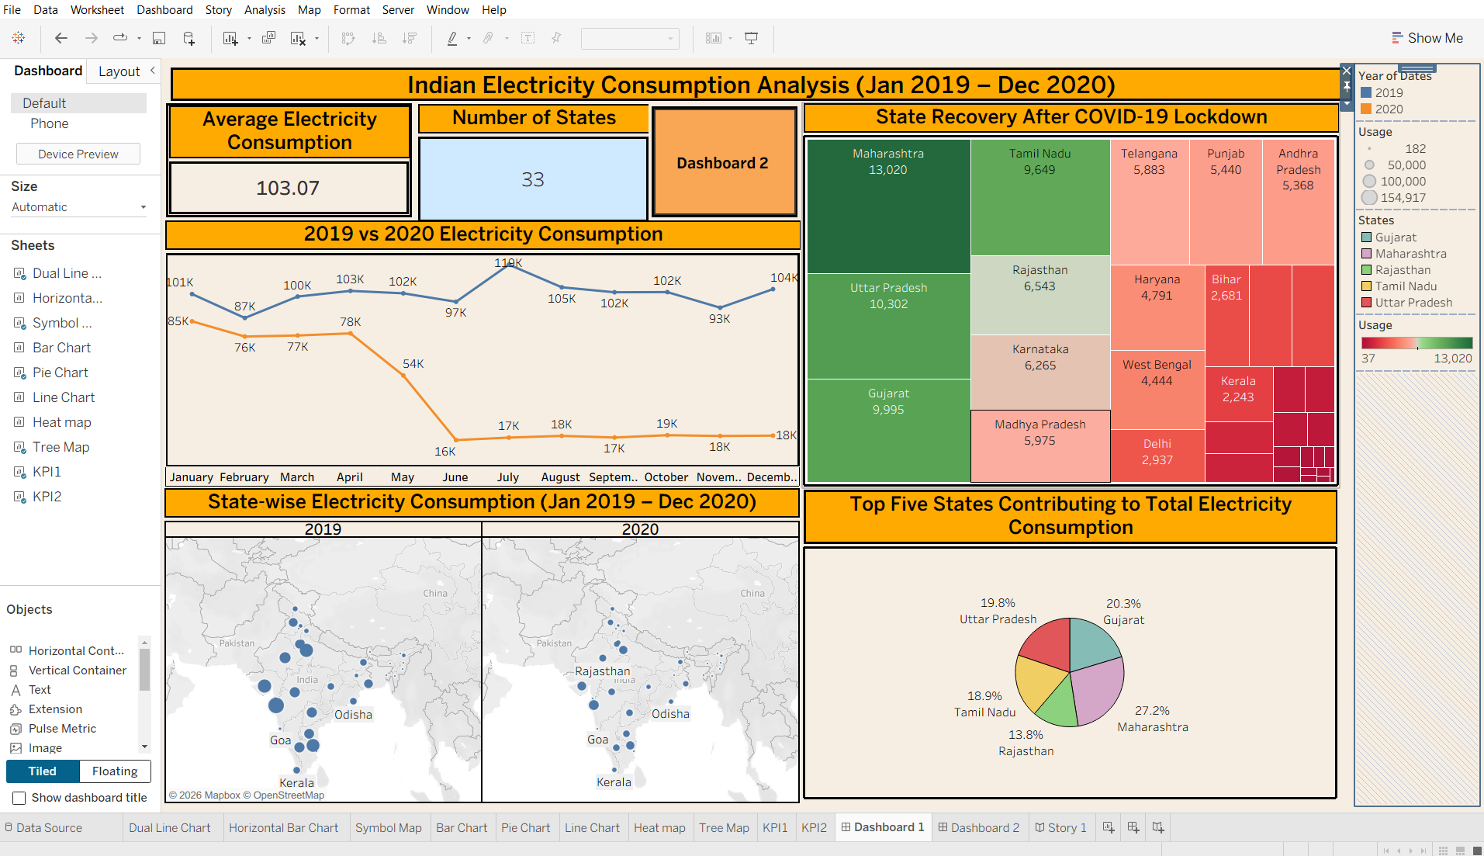

Dashboard 2
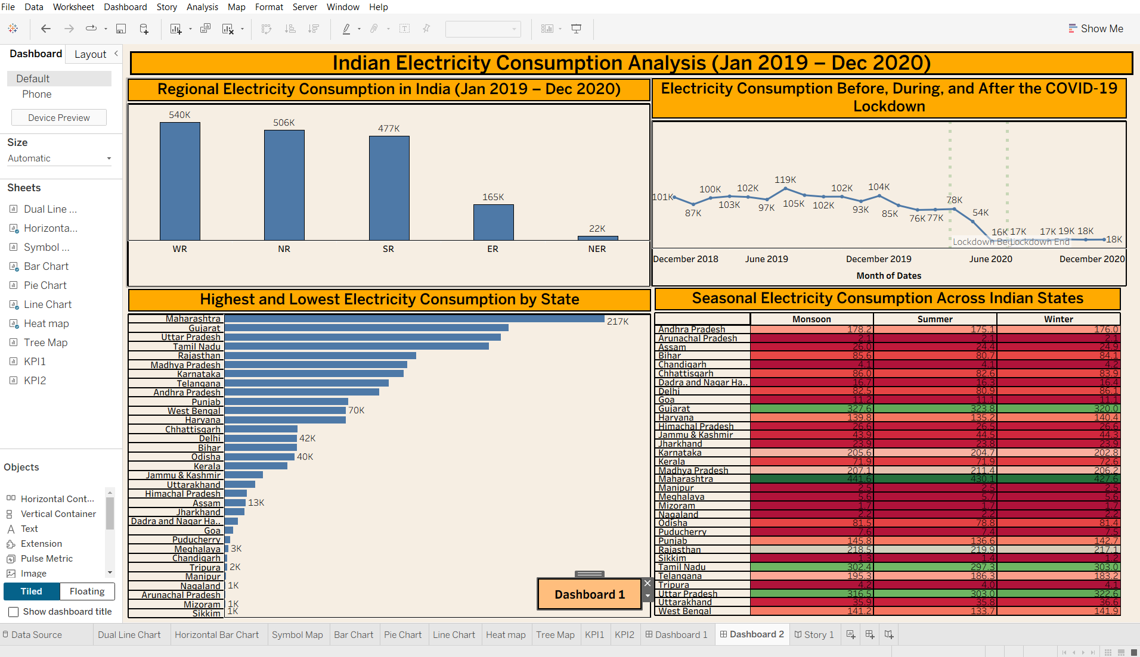

Story Screenshot
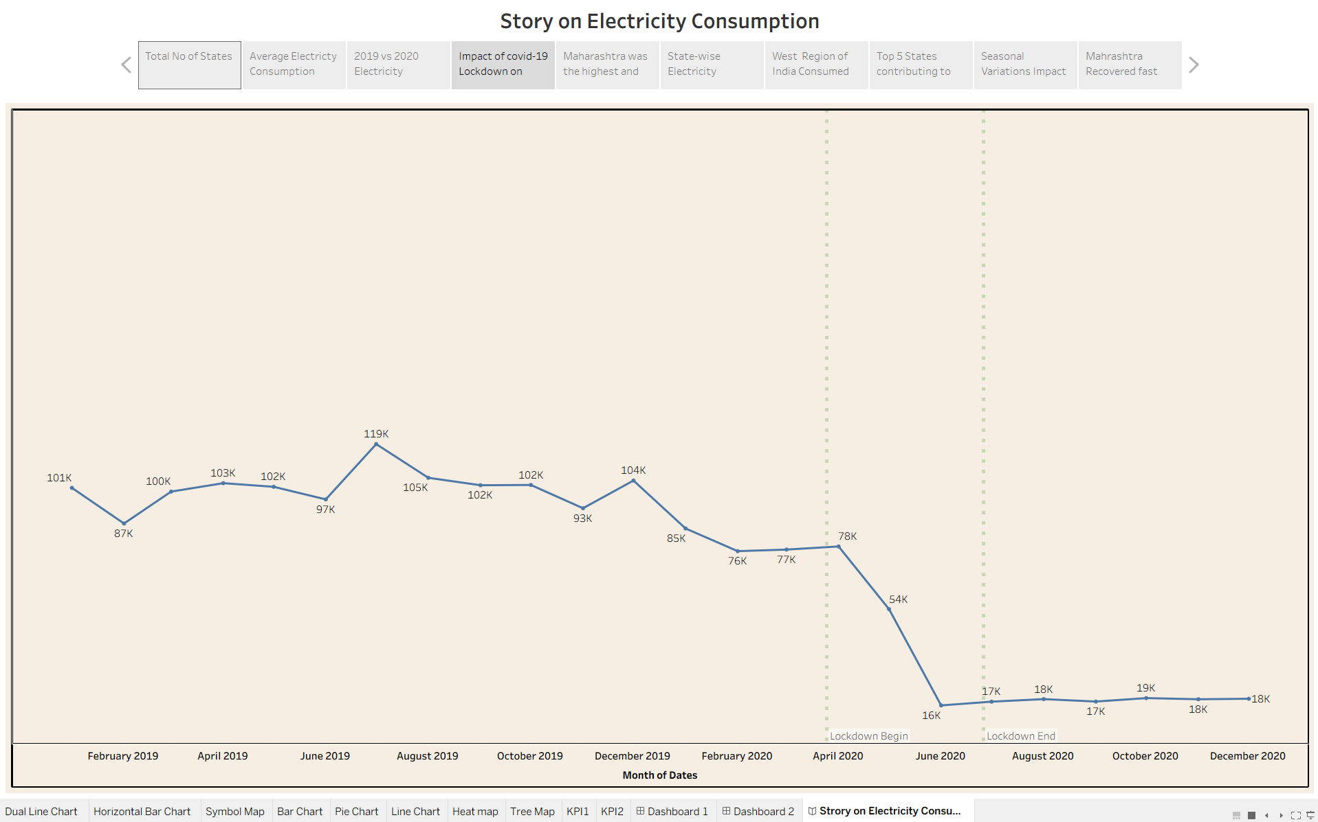

Tableau public link of Dashboard and story (workbook)
https://public.tableau.com/views/ElectricityConsumptionAnalysis20192020/LineChart?:language=en-GB&publish=yes&:sid=&:redirect=auth&:display_count=n&:origin=viz_share_link

